LANGUAGE TRANSLATION USING DEEP LEARNING

A PROJECT REPORT

Submitted by

JUMANA BEGUM J (2019103022)
JESIMA A (2019103529)

for the course

CS 6005 – DEEP LEARNING TECHNIQUES

DEPARTMENT OF COMPUTER SCIENCE AND ENGINEERING, COLLEGE OF ENGINEERING, GUINDY
ANNA UNIVERSITY
CHENNAI 600 025

DECEMBER 2022
ABSTRACT

Machine Translation has become indispensable in the present tech-savvy world to reduce the linguistic barrier across borders. English is the most extensively spoken language worldwide; therefore, it becomes essential to translate information from English to native languages. Early solutions for machine translation used rule-based and statistical techniques. A paradigm shift from statistical to neural models happened in recent years giving rise to Neural Machine Translation, making it one of the most powerful approaches. We propose to develop a Neural Machine Translation based Sequence-to-Sequence LSTM-based Encoder-Decoder model to translate English to French. Seq2Seq LSTM uses layers of LSTM to create a hidden representation of the input sequence using the hidden representations from the previous time steps and uses this hidden sequence to decode the sequence in the target language. The Bilingual Evaluation Understudy (BLEU) metric is used to evaluate the quality of the translations.

BLOCK DIAGRAM

Figure 1 shows the block diagram of the project.

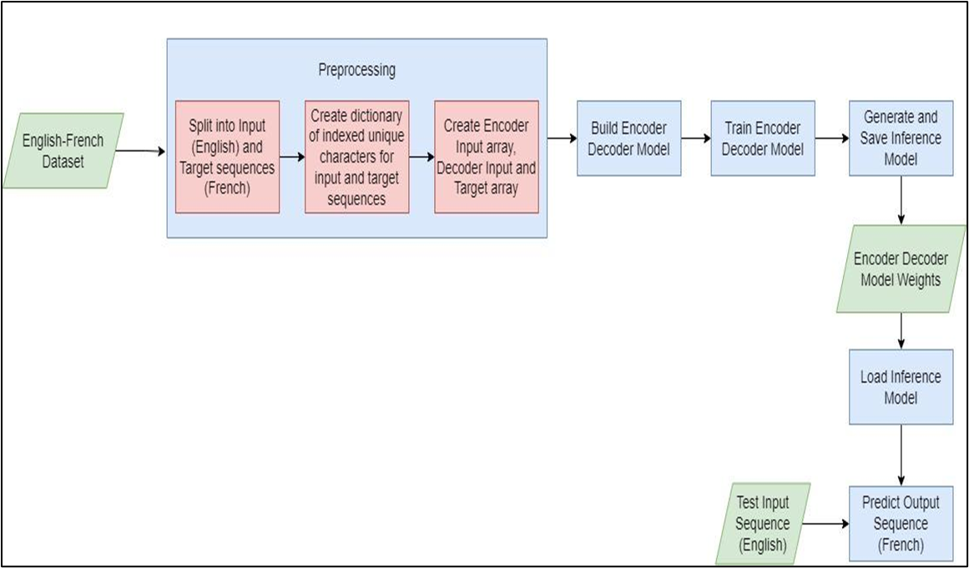

Figure 1: Block Diagram

NETWORK ARCHITECTURE
We have used an encoder decoder architecture using LSTMs. The encoder has an input layer, an LSTM layer with 1024 LSTM cells. The decoder has an input layer, an LSTM layer with 1024 LSTM cells and a dense layer with softmax activation. Figure 2 shows the summary of the network architecture.
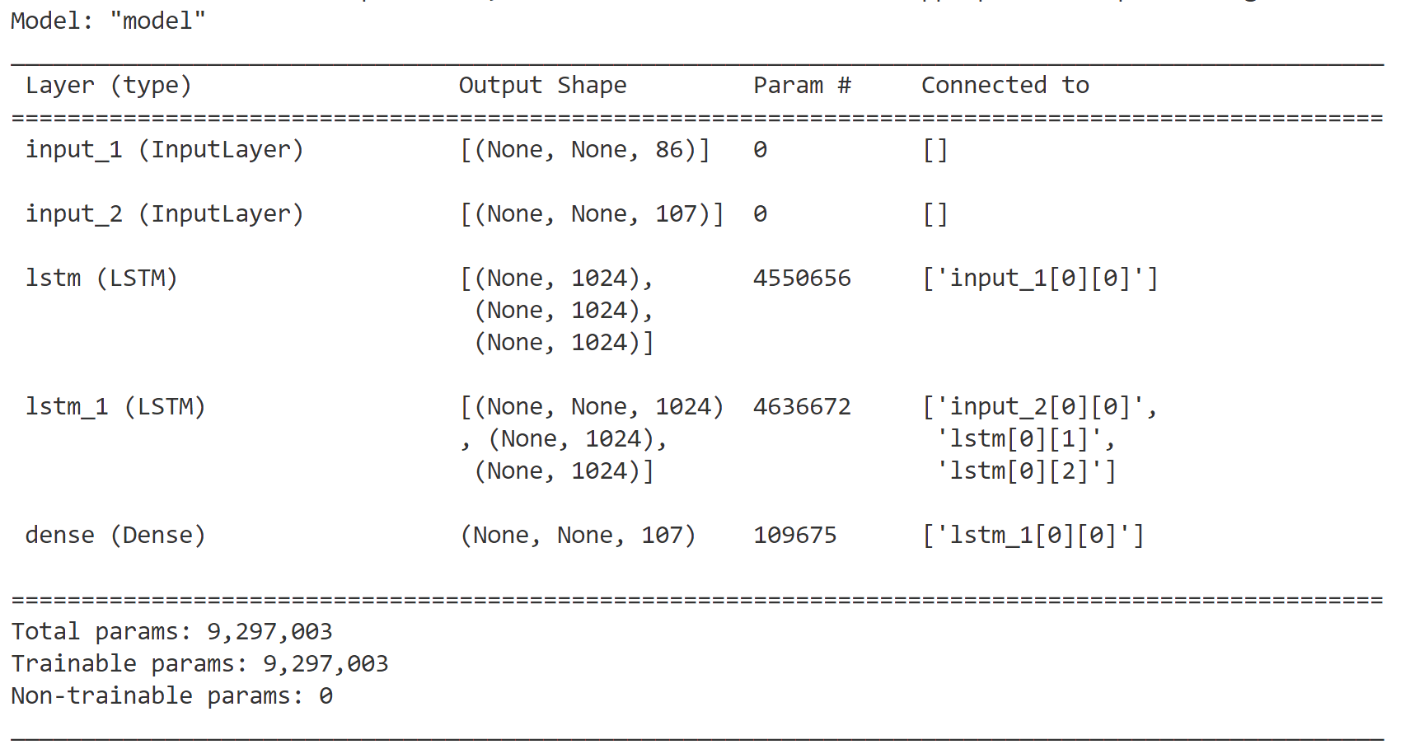

Figure 2: Network Architecture

DATASET DESCRIPTION
We have used the ANKI Dataset which are Tab-delimited Bilingual Sentence Pairs. Each entry in the dataset is of the format:

English Sentence + TAB + French Sentence + TAB + Attribution.

The attribution contains the domain name of the source material, the sentences' ID numbers and the sentence owners' usernames and can be ignored. The dataset has 1,97,463 pairs of english-french sentences. The sample of the dataset is given in figure 3. The original ANKI English-French dataset can be found here.

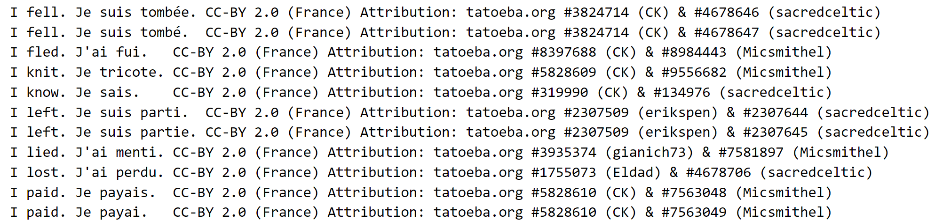

Figure 3: The sample of the dataset with English-French sentence pairs

IMPLEMENTATION

We have implemented the solution in five submodules.

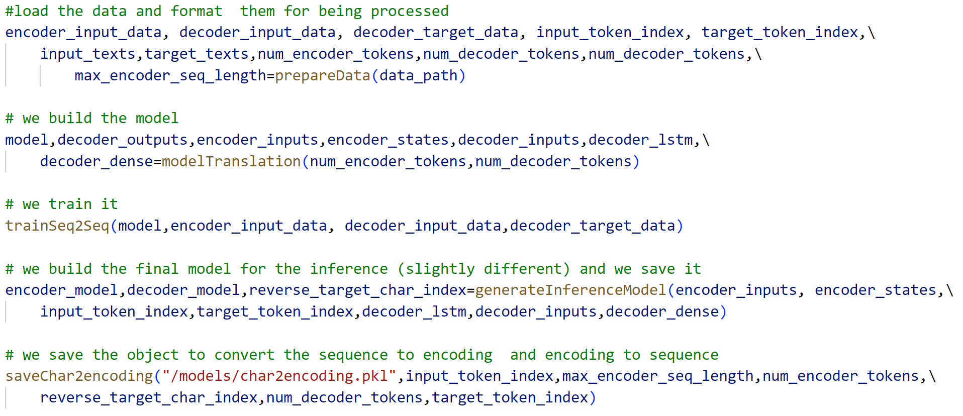
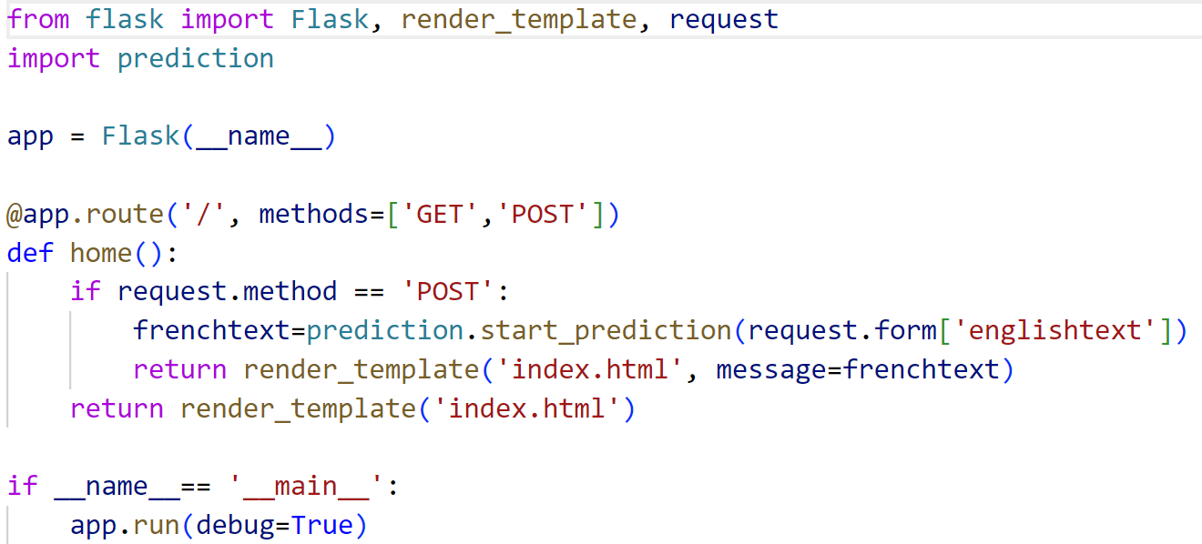

- Data preprocessing
Firstly, English and French sentences are separated. The number of unique English and French characters in the sentences are calculated. The sentence with maximum length is found for both English and French languages. A dictionary is created for both languages with character as the key and index as the value. A 3D matrix is created for encoder input data, decoder input data and decoder target data. The presence of the character is marked as 1 in the matrices.

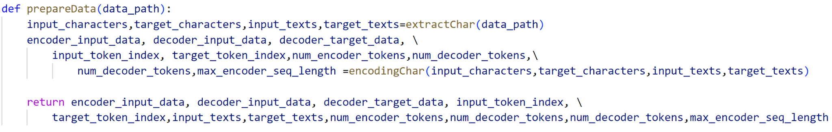
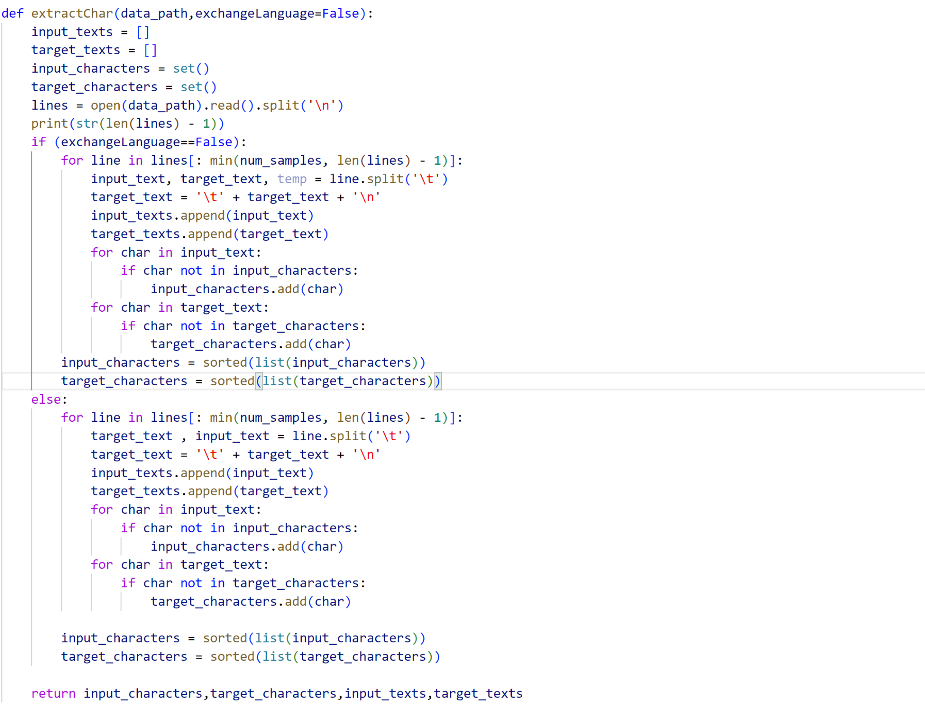
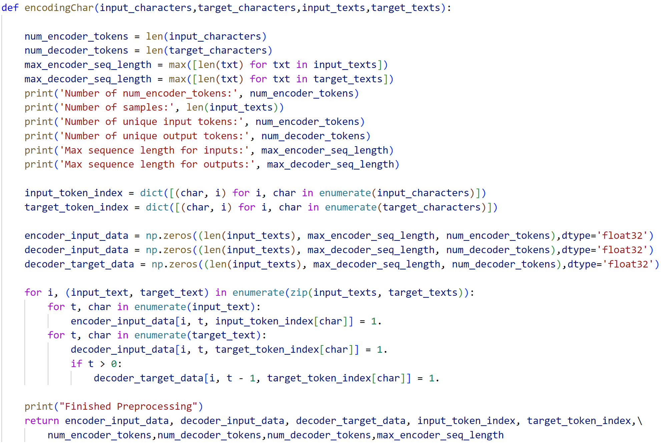
- Encoder Decoder Model Build
The model is created with one encoder(LSTM) , one decoder (LSTM) and one Dense layer with softmax activation function.

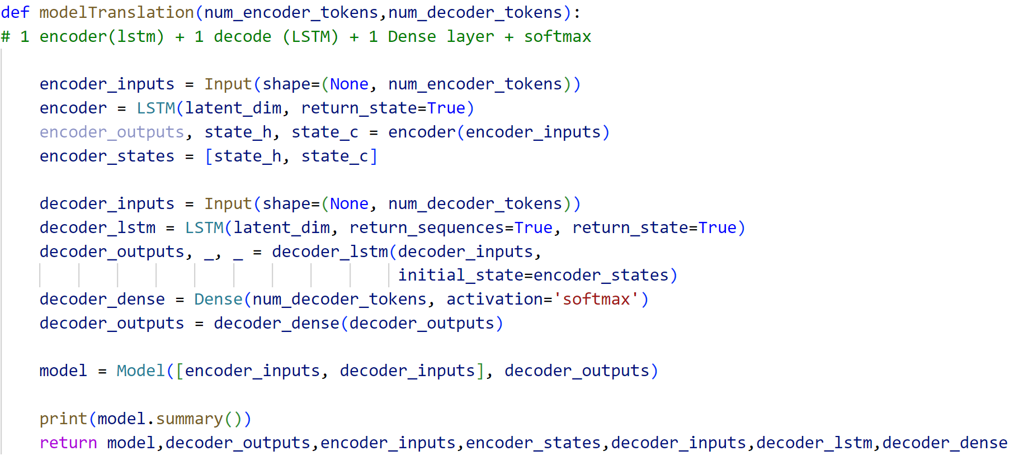

- Training
The model is compiled using rmsprop optimizer with categorical cross entropy as loss and accuracy as metrics.The model is trained for twenty epochs with the encoder input data, decoder input data and decoder target data.

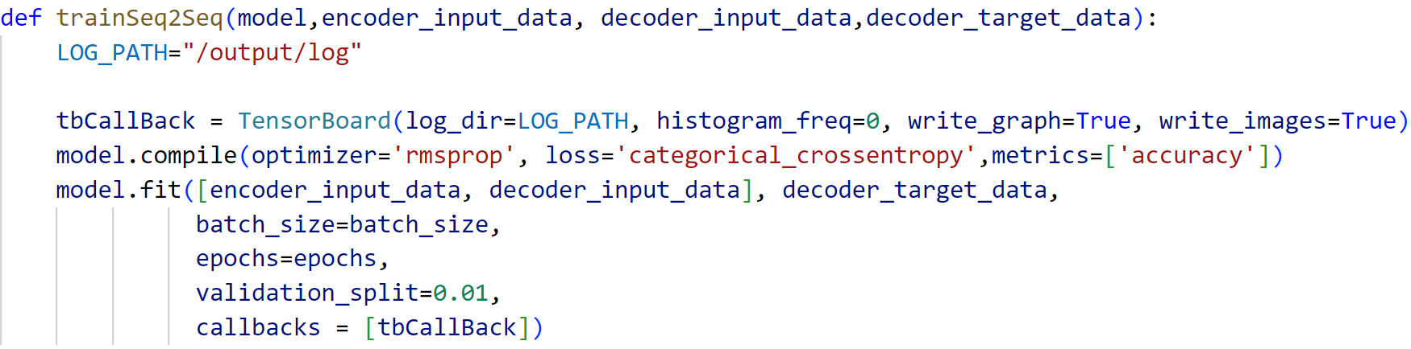
- Inference Model Build
The model is trained on the training dataset and the resultant encoder, decoder and the dense layer are connected to create an inference model. A reverse lookup token index is created for decoding the sentences. A reverse lookup token index has index as the key and character as the value. The inference encoder decoder model is saved along with the other parameters.
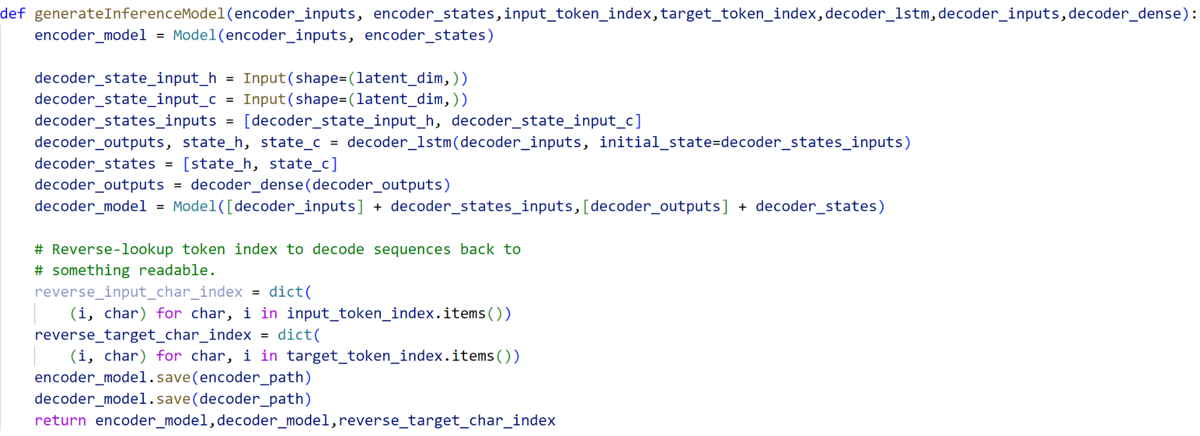
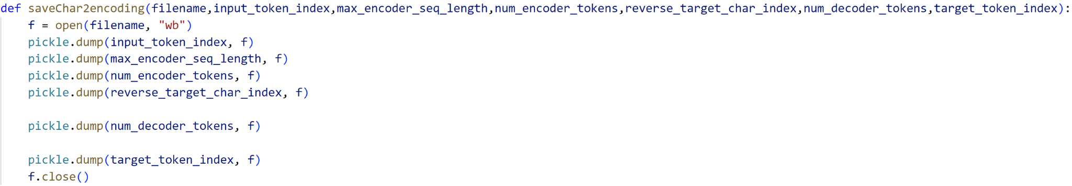

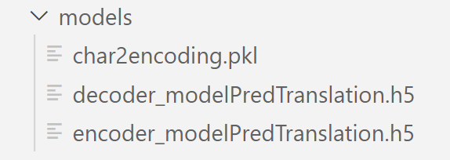

- Testing
The inference model is unpickled and loaded. The input sentence is encoded in the encoder_input_data matrix. The inference model is used to predict the target sequence.

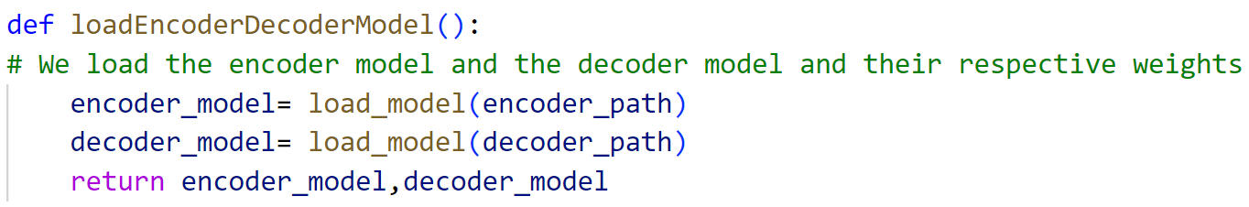
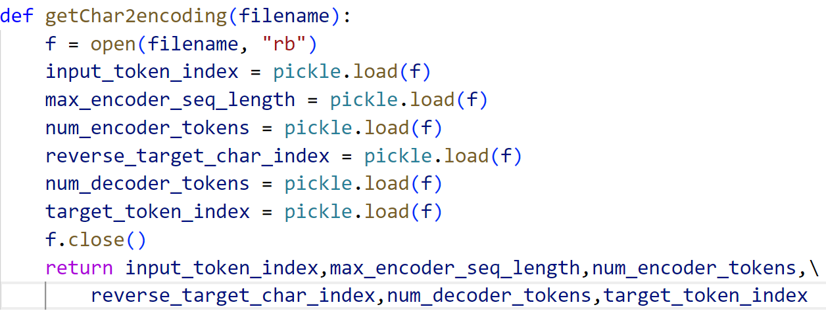
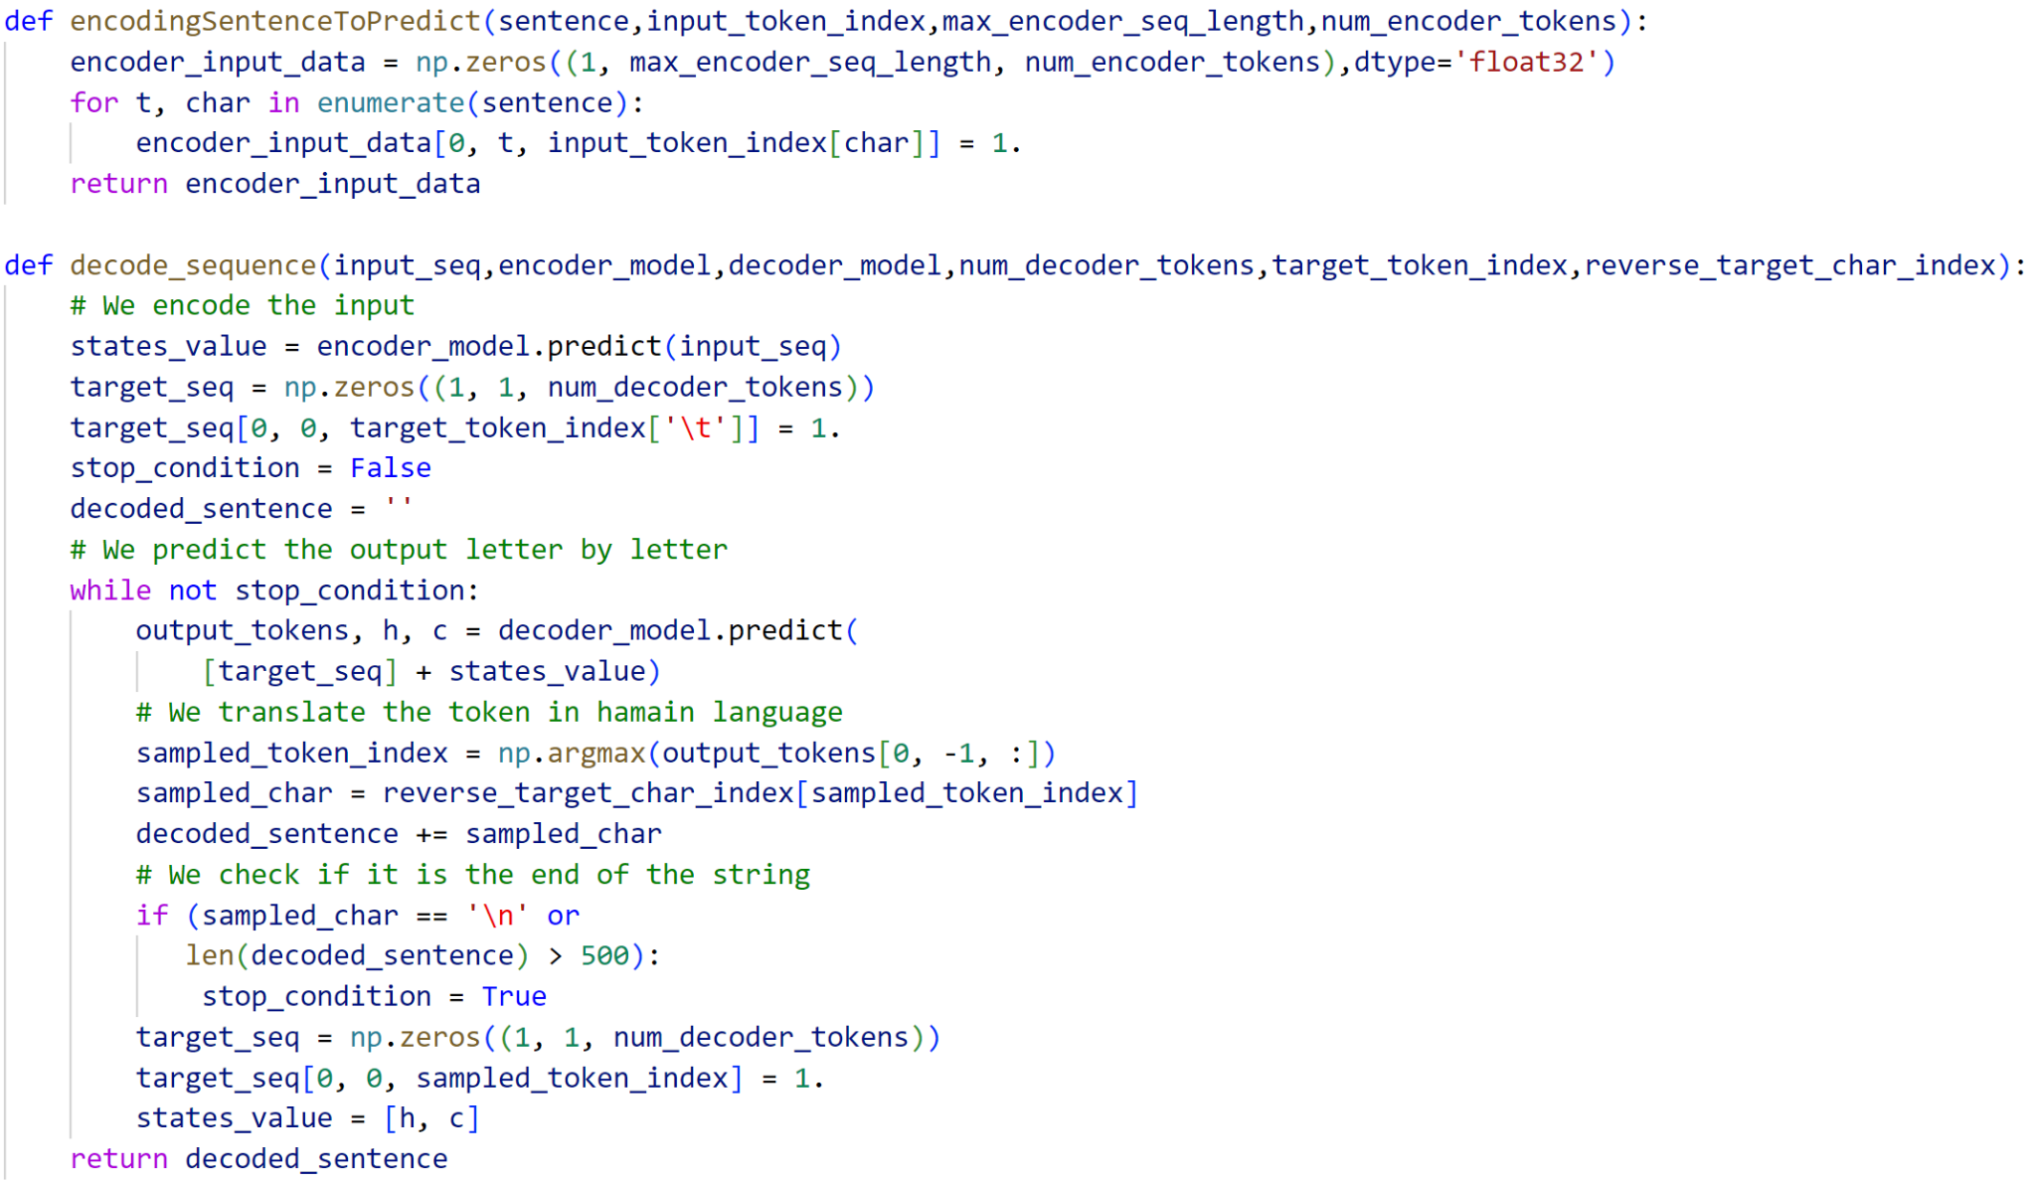
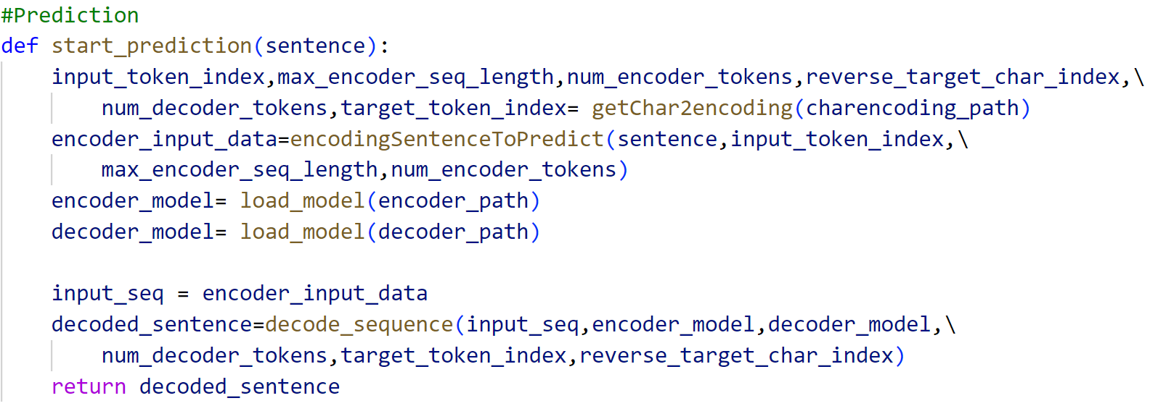
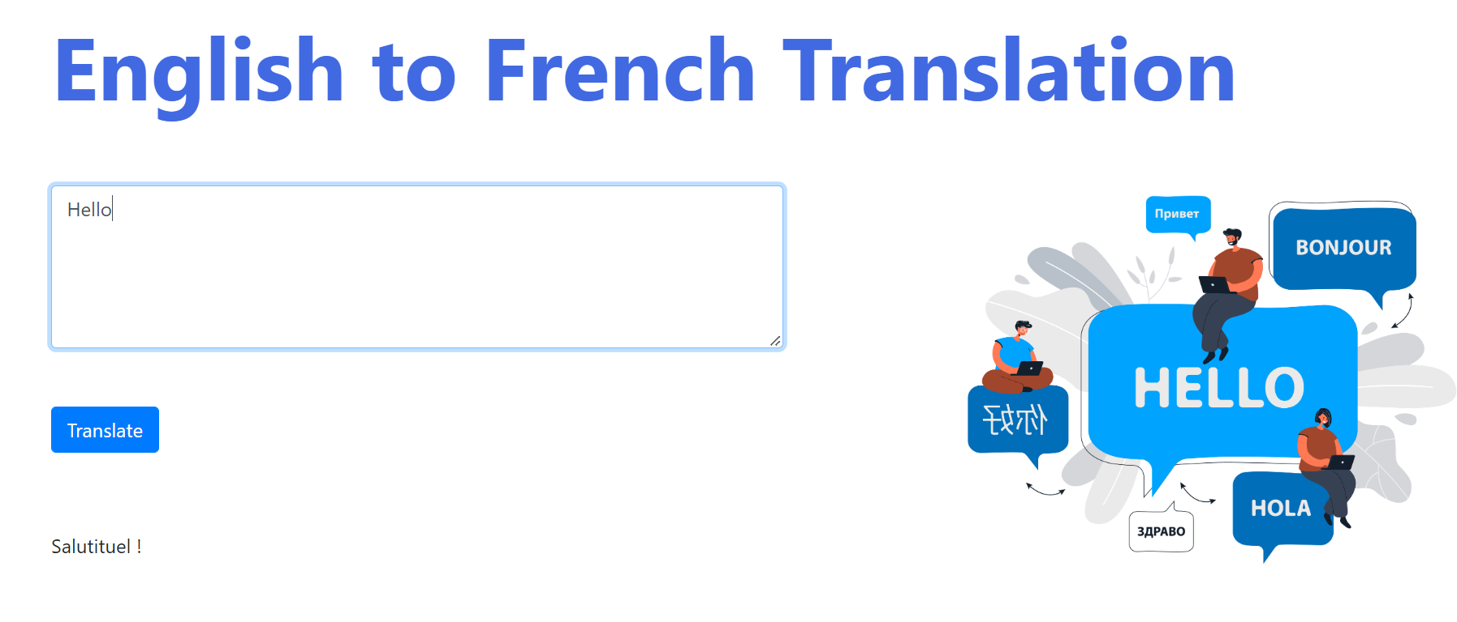

RESULT ANALYSIS

BLEU score is used as a metric to compare the actual and predicted data. BLEU score of 0.3-0.4 is observed.

REFERENCES
[1] Sindhu, C., Guha, S., & Panwar, Y. S. (2022, March). English To Hindi Translator Using Seq2seq Model. In 2022 8th International Conference on Advanced Computing and Communication Systems (ICACCS) (Vol. 1, pp. 266-271). IEEE.
[2] http://www.manythings.org/anki/

